**Alibaba’s Future**

**Description of Business**

Alibaba started as a B2B marketplace in 1999. Jack Ma and his friends founded it in 1999 during the dot com rise in his apartment. Today it is the second-largest e-commerce platform lagging only Amazon and the most valuable company in Asia in 2019 by market cap. Besides e-commerce, the company also operate three different segments known as Cloud Computing, Digital Media and Entertainment and Innovation initiatives and others. Below is a revenue breakdown by segment and companies in each segment.

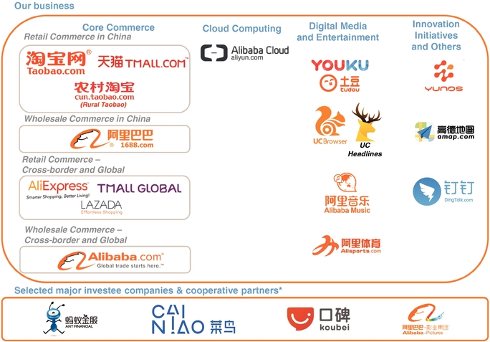

<https://www.sec.gov/Archives/edgar/data/1577552/000104746917004019/a2231121z20-f.htm>

Core Commerce: 86%

Cloud Computing: 7%

Digital media and entertainment: 6%

Innovation initiatives and others: 1%

From Alibaba Group Holding Limited 20-F Filled on Jun-05-2019

Alibaba has experienced success over the last two decades from having the highest IPO price for a technology stock ever at the time it public to where it is today. In the upcoming months there will be multiple key events happening. The events are analyzed below.

1. **Jack Ma’s departure**

For the last two decades when you talk about Alibaba the first name that comes to mind has been Jack Ma. Alibaba has been quietly changing that over the last few years with the last few step being taken on September 10th of 2018. On that day Jack Ma announced he will be stepping down from the position of Chairman at Alibaba in the coming year. Following that it has been reported that Jack Ma will be leaving the BOD after 2020 shareholders meeting which will be happening in June.

**********************************************************************************

**My thoughts (This is my opinion)**

The price of Alibaba stock has priced in Jack Ma’s departure. He has spent the past few year slowly preparing Alibaba for this day. Starting from stepping down from CEO to stepping down from chairman to eventually leaving the BOD soon.

Jack Ma’s successor, Daniel Zhang (seen on the left) should be able to take Alibaba greater heights although there will definitely be setback along the way as Alibaba’s main revenue segment, core commerce has reached maturity stage of the business growth cycle. Mr. Zhang would need to deploy a strategy that will continue to allow Alibaba’s revenue to grow at the rate it has in past years. Given Mr. Zhang track record of inventing Single’s Day that contributes to Alibaba recording breaking revenue every year, it is possible to believe he will come up with a strategy that will assist Alibaba to continue growing.

**********************************************************************************

1. **Rising US and China Tension**

Before COVID-19 hit US and China were under trade war that had investors predicting Alibaba would take a significant hit from as it would slow the growth of its expansion into the US and reduced consumer buying power in China due to tariffs applied on certain good. On January 15th 2020 the two country agreed on a phase 1 deal where both side agreed to rollback a portion of the tariffs, this led the market to believe that the tension between the two country was going back to normal. However it is possible that tension will come back as President Trump has been declaring for China to pay for the damage caused to other nation by COVID-19. At the same time China’s plan to take control of Hong Kong will not fair well between the two nations.

**********************************************************************************

**My thoughts (This is my opinion)**

Alibaba has shown through the US and China trade war that it could continue to operate and grow as the trade war caused Chinese to buy more goods domestically and did not slow Alibaba’s earnings much. Although revenue could take a hit as international commerce and retail made up 7% of total revenue and _% of total commerce revenue.

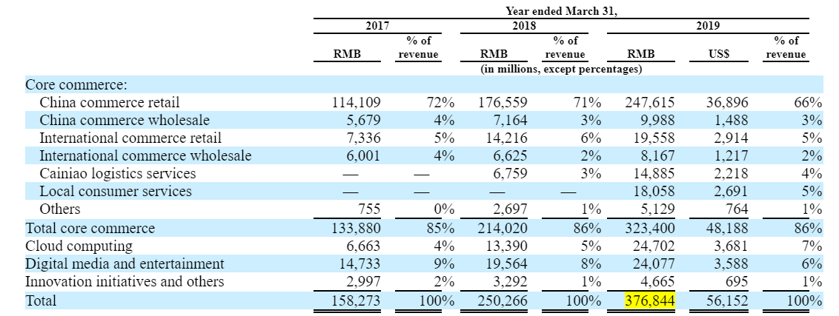

**********************************************************************************

1. **Senate passing HFCAA on US regulated listing**

On May 20th the senates passed Holding Foreign Companies Accountable Act (HFCAA). The purpose of this act is to ensure companies that are listed on the US stock exchange are not owned or controlled by a foreign government. This act is viewed as targeted towards China, in the past Chinese companies have denied access to its audited work stating that it is against the Chinese laws for those documents to leave the country. The legislation still needs to be passed by the House of Representative before being passed onto President Trump.

**********************************************************************************

**My Thoughts (My opinion)**

If the legislation ends up getting pass the House of Representative and President Trump. It could lead to potential movement in the stock price as Alibaba is one of the 165 companies that was listed by SEC in 2019 to be affected by the legislation. If the worst case scenario of delisting occurs the stock will take a huge hit as investors will look to sell off before the stock becomes illiquid. This problem was also addressed on Q1 conference call as the projection of earnings growth was dropped to a lower amount due to multiple factors including this legislation.

**********************************************************************************